**NCC**

**ABSTRACT**

This report critically evaluates the Bean Boutique website, focusing on the technologies and approaches used in its development. It examines the back-end components, the selection and utilization of plugins, the importance of version control and GitHub, and the potential benefits of a front-end framework. The analysis delves into Woo Commerce, Yeast SEO, and Contact Form 7 plugins, assessing their alignment with business needs. The discussion on version control highlights the significance of managing codebase changes and enabling collaboration. The report also identifies the website's unique selling points, including effective customer communication and value-adding capabilities, and provides recommendations for further improvements.

**TABLE OF CONTENTS**

ABSTRACT……………………………………………………….ii

TABLE OF CONTENTS:………………………………………...iii

TASK 1 :HTML…………………………………………………..1

TASK 2: CSS.……………………………………...……………..7

TASK 3 :Website testing and report……………………………..9

1.0: HTML and CSS code check with W3C ...............................10

1.1: Accessibility test...................................................................11

1.2: Summary….………………………………………………...12

1.3: Report..……………………………………………………..15

TASK 4: Analysis Report……………………………………......8

# TASK 1: HTML

**HTML for the Bean Coffee Website**

**Home page html**

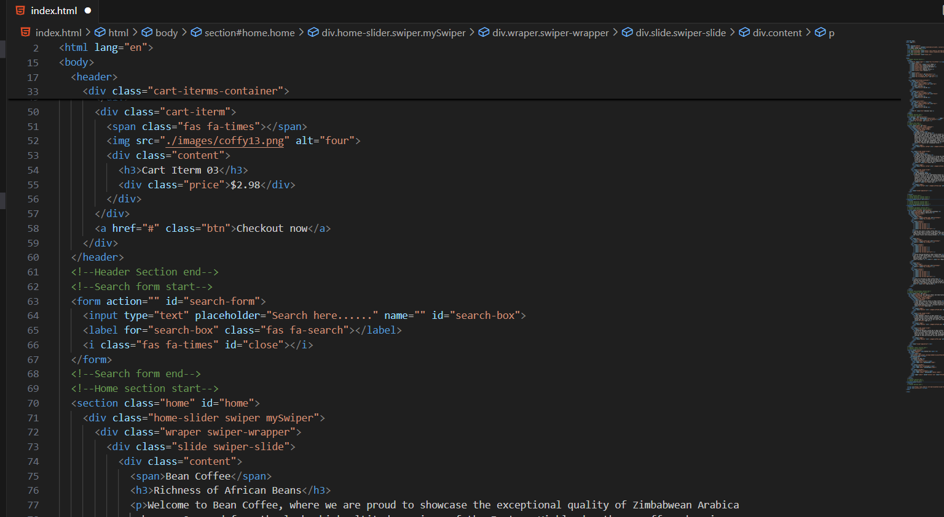

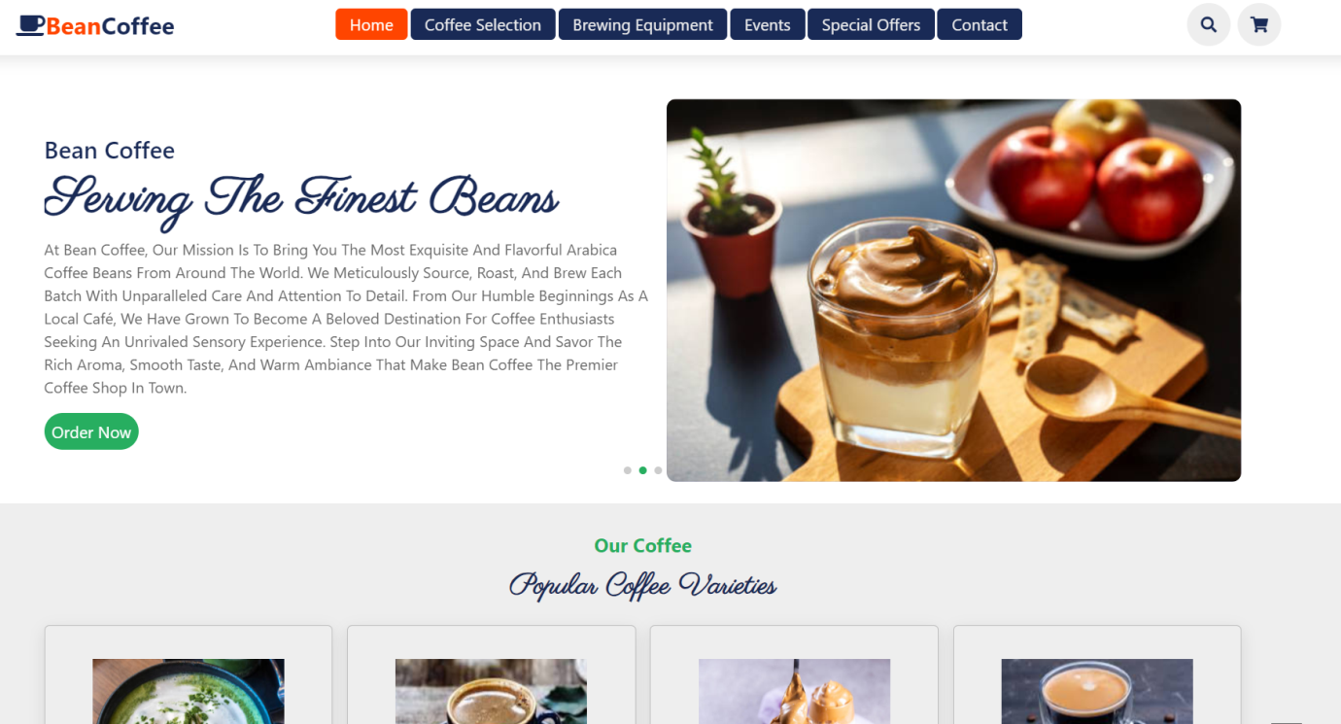

**Coffee Selection page html**

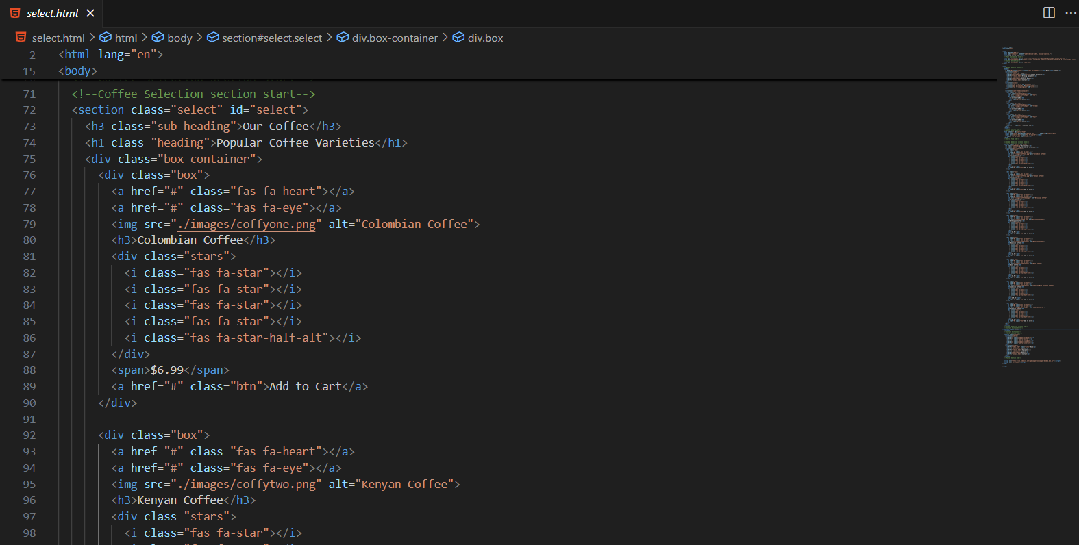

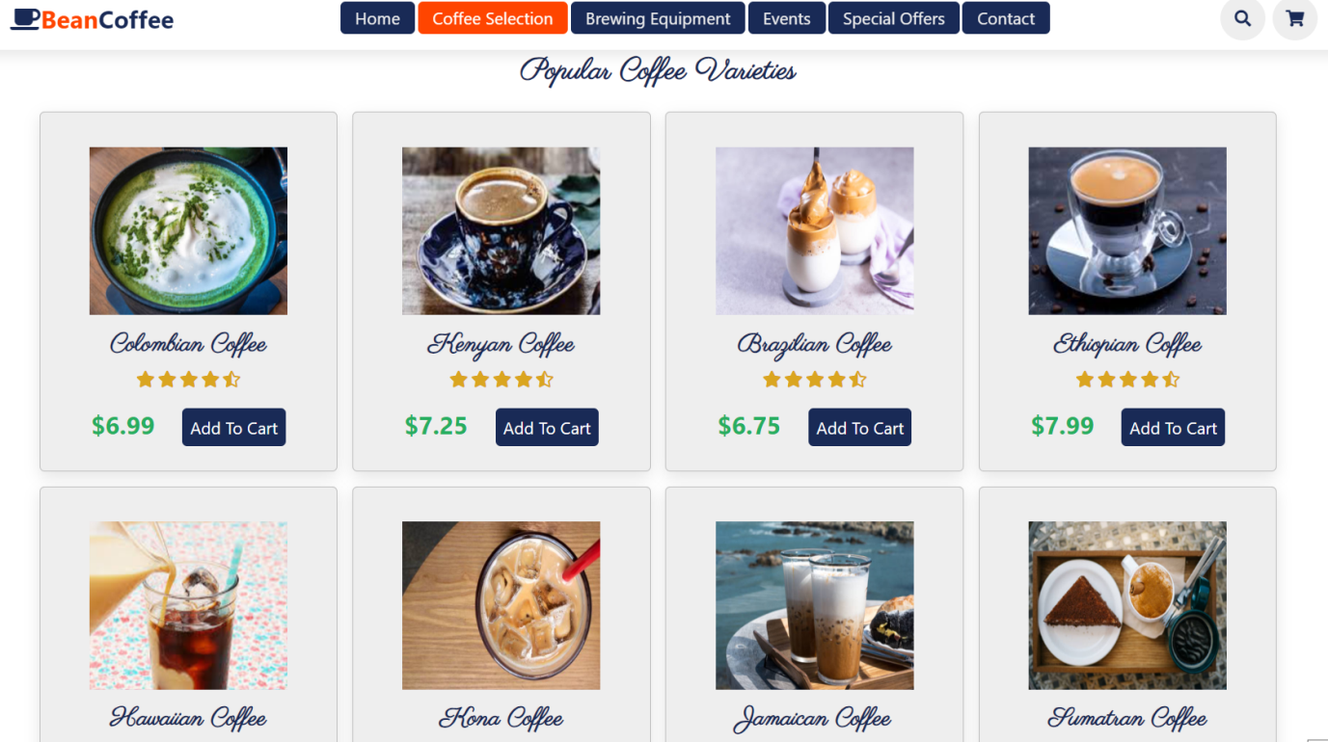

**Brewing Equipment page html**

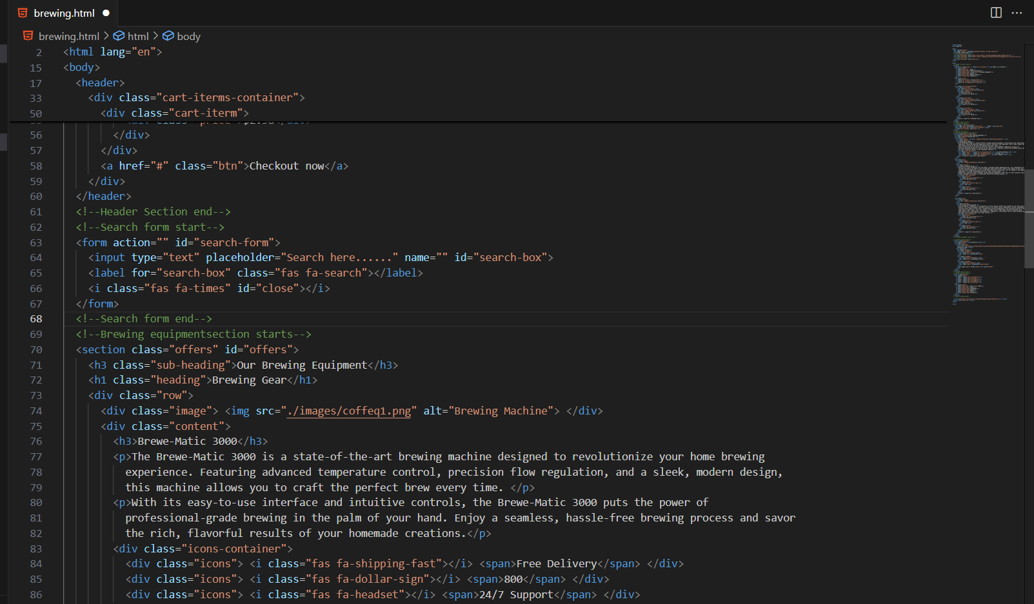

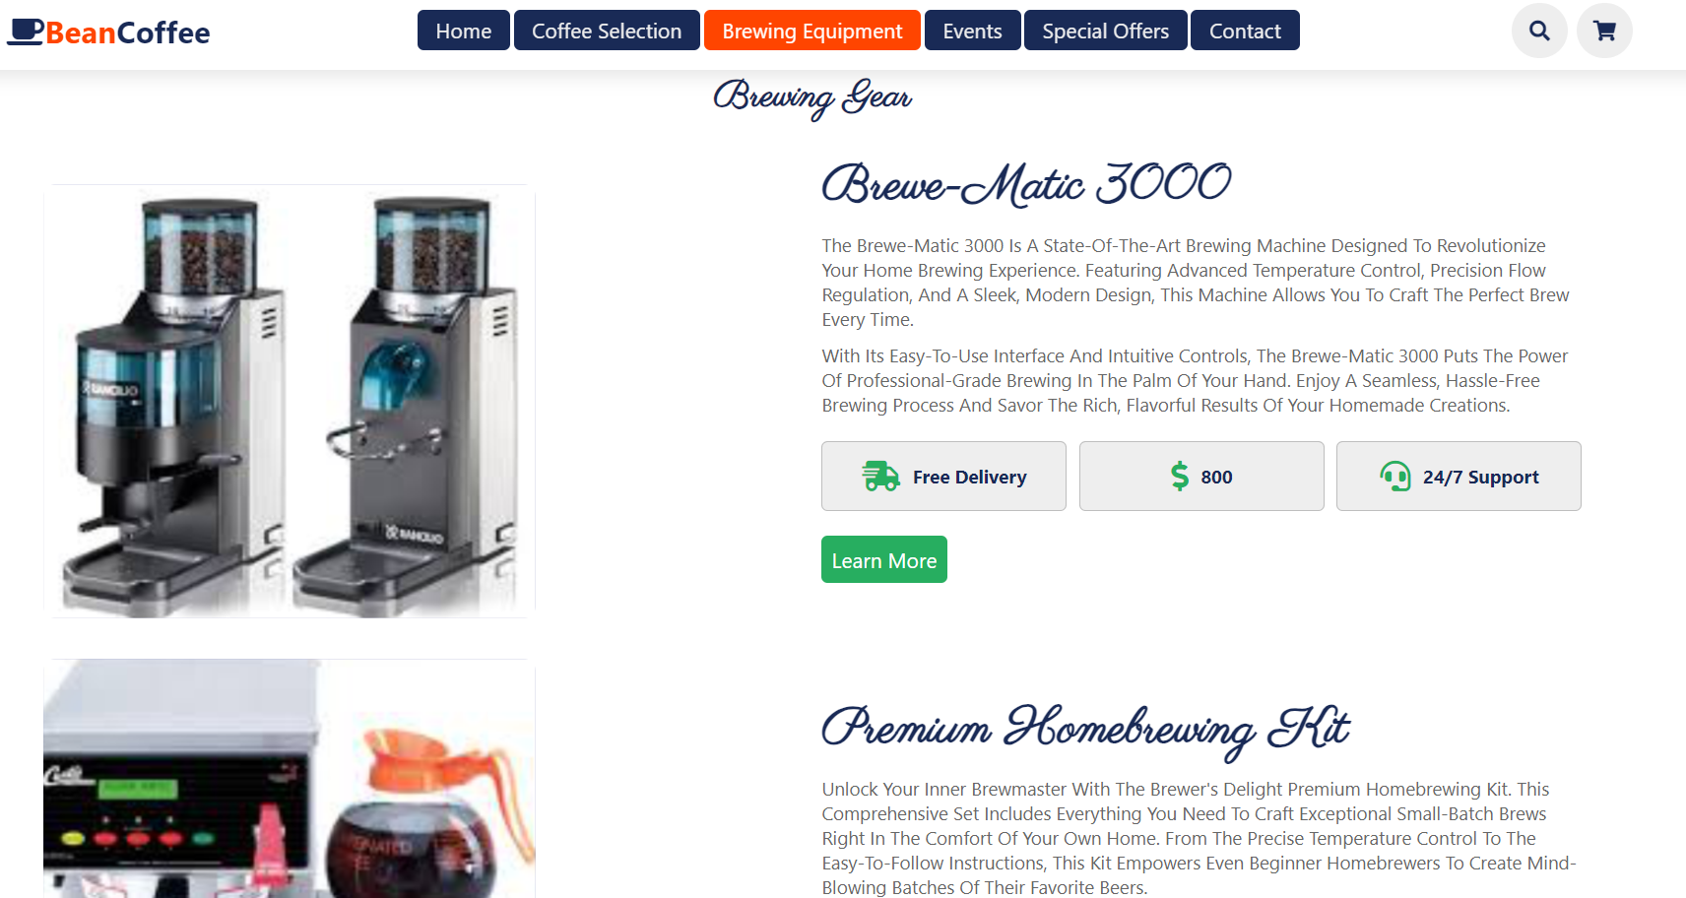

**Events and workshops page html**

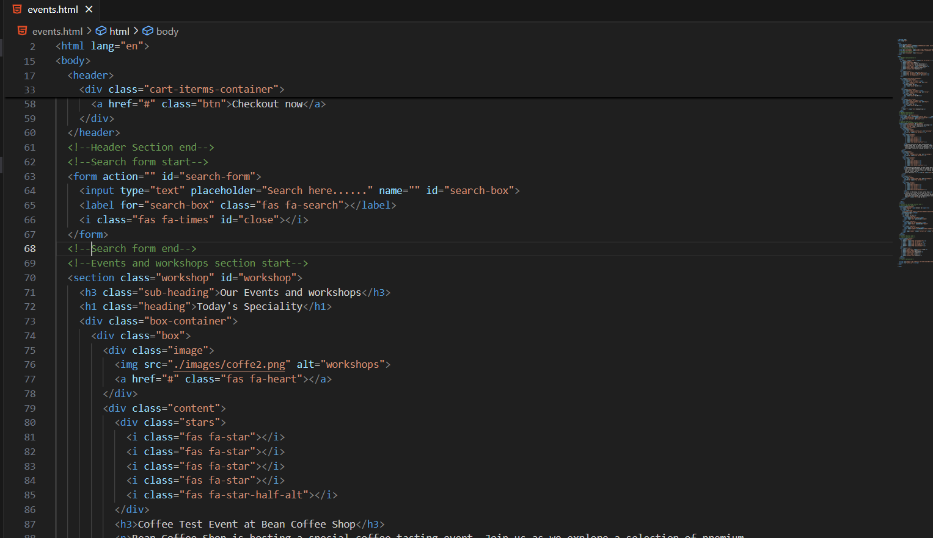

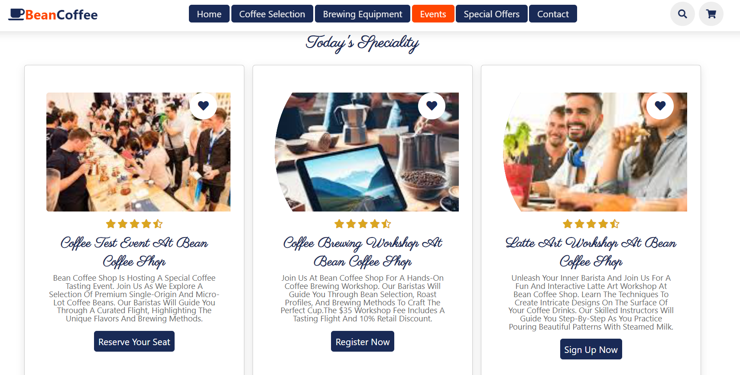

**Special offers and subscriptions page html**

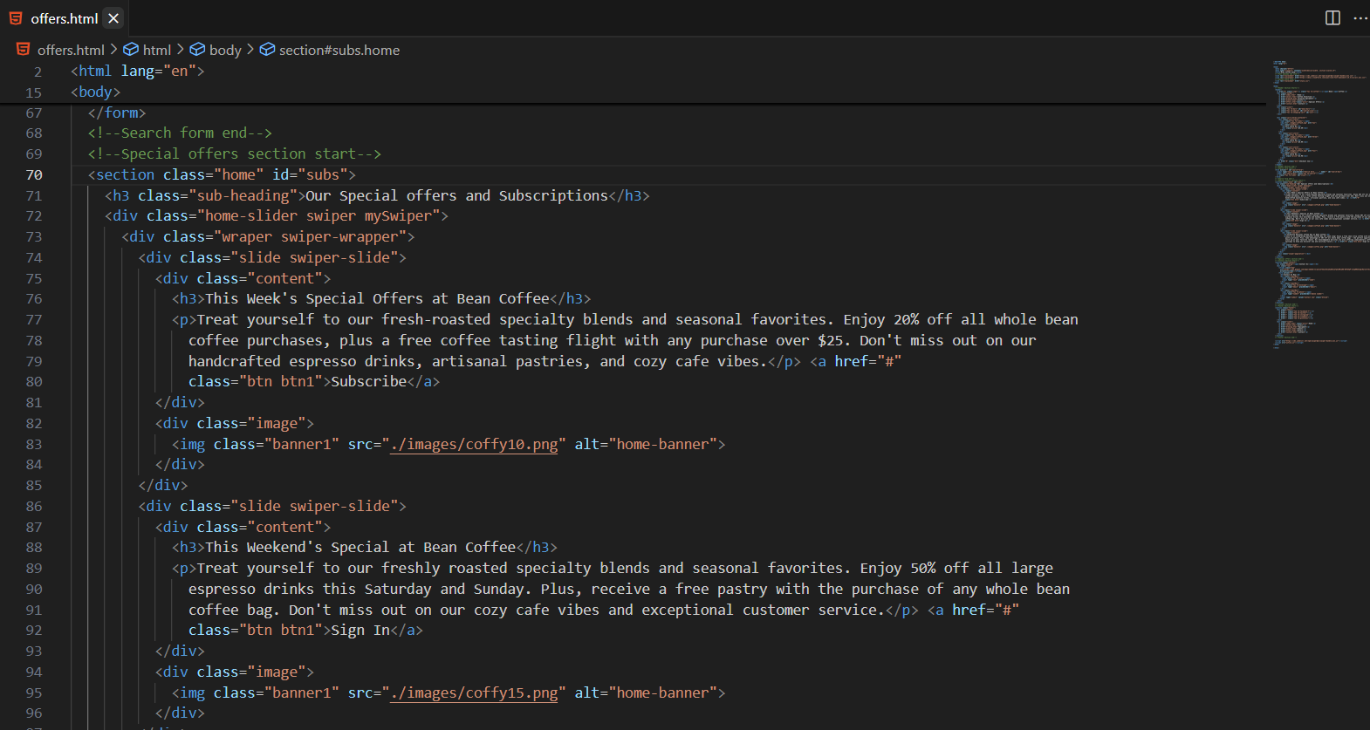

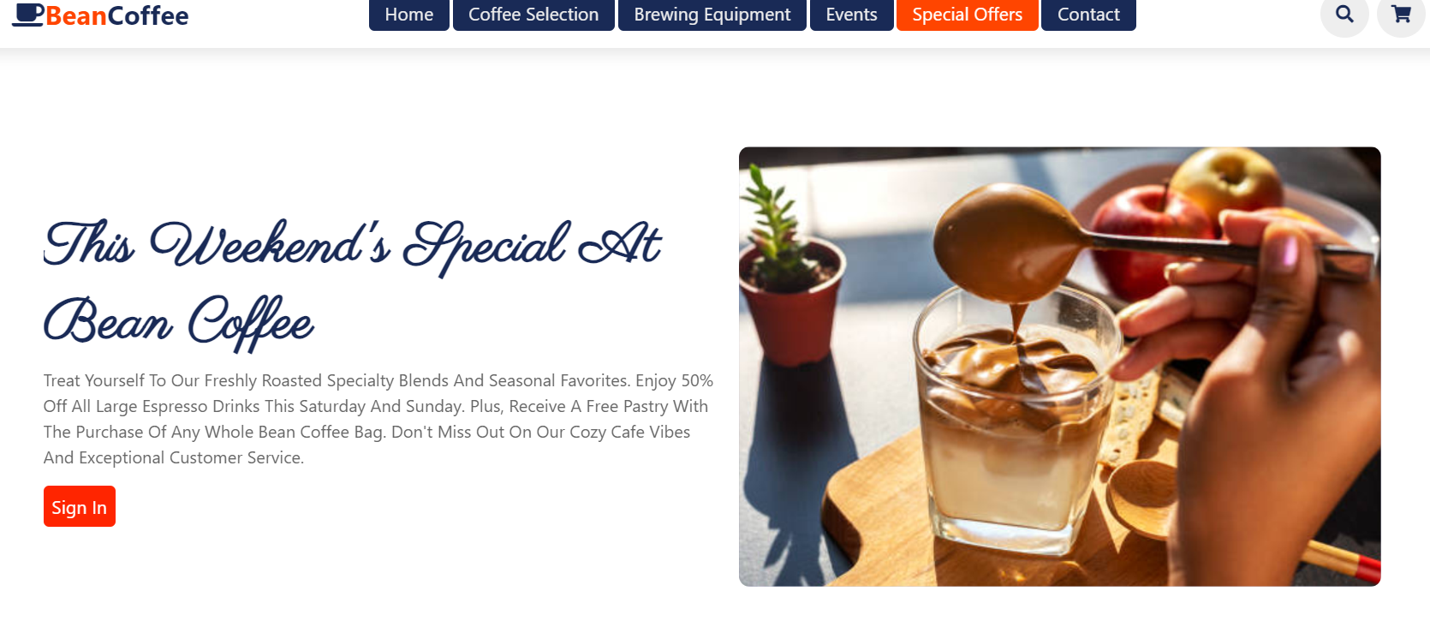

**Contact page html**

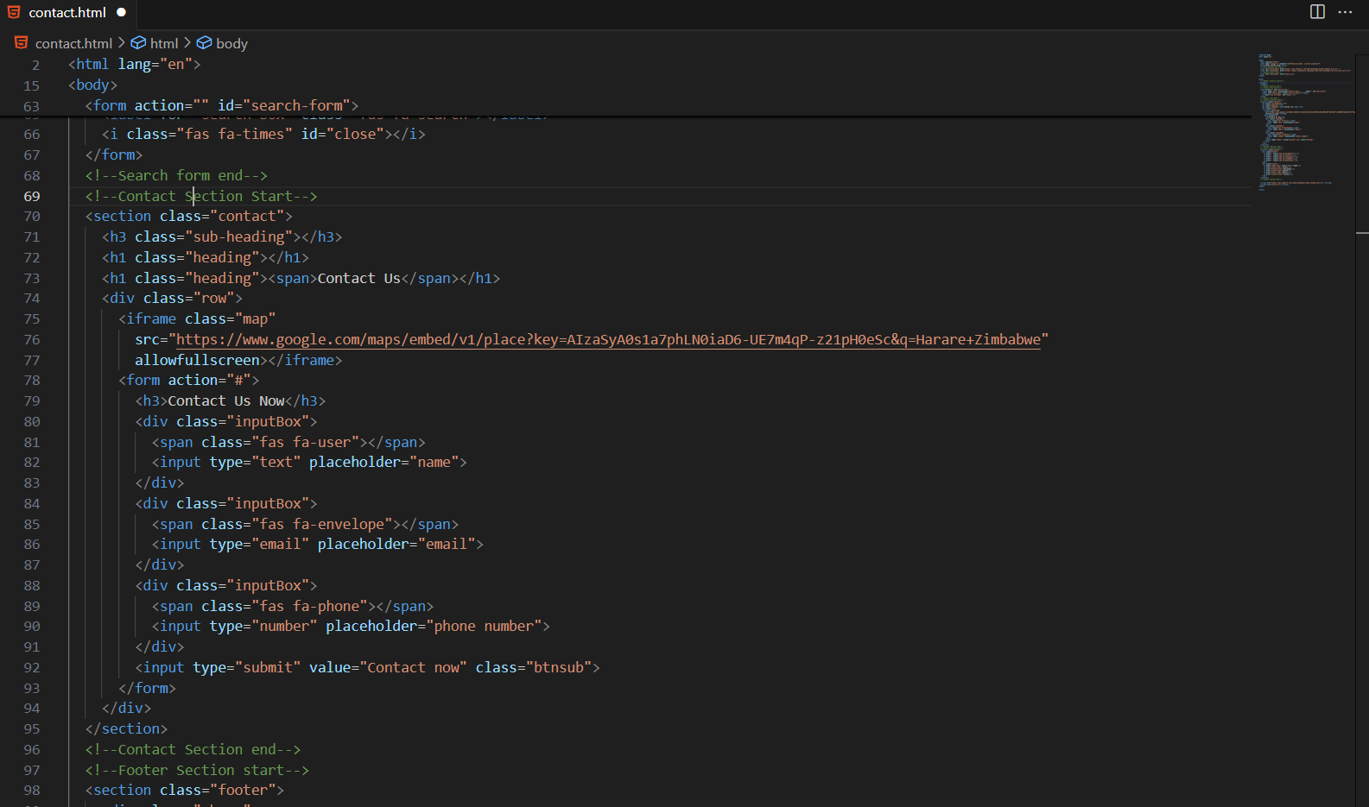

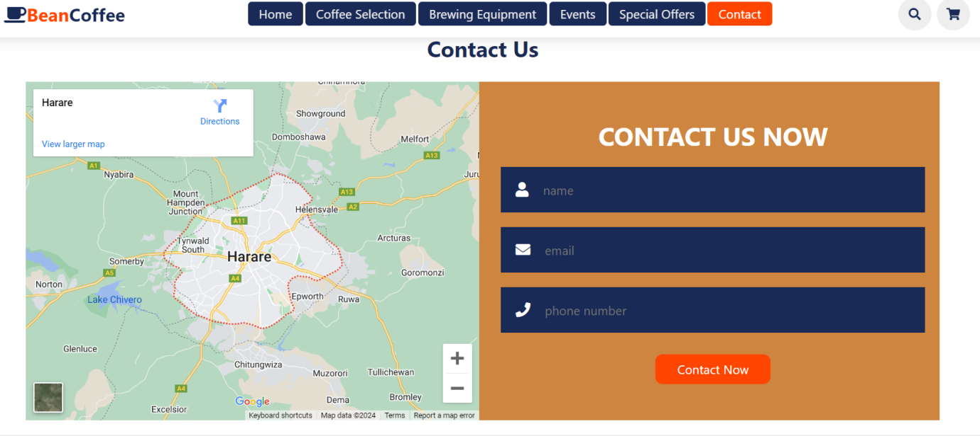

**Task 2: CSS**

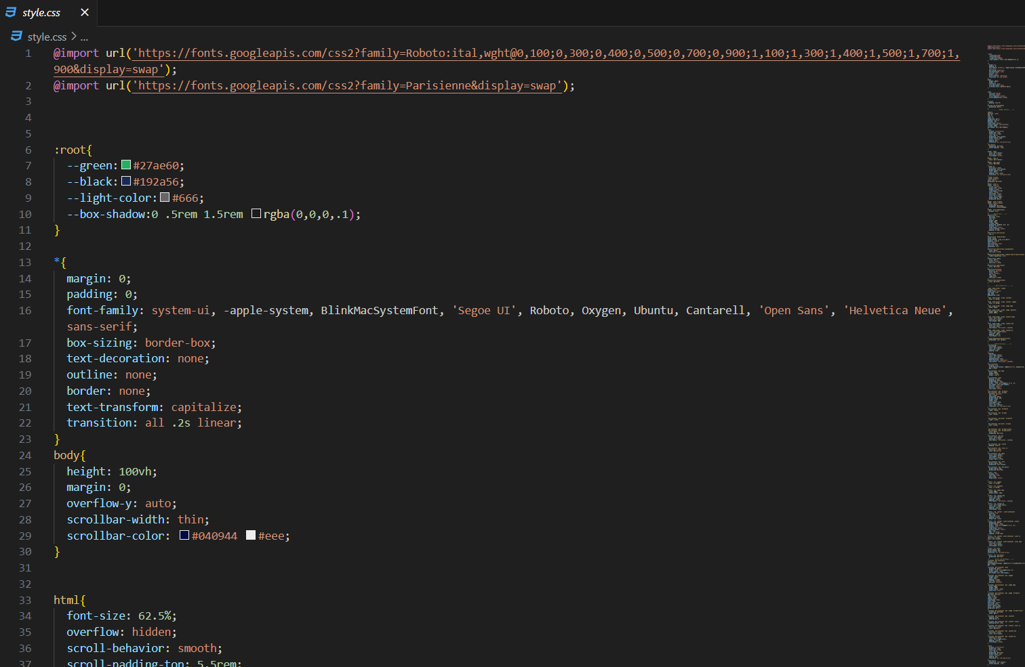

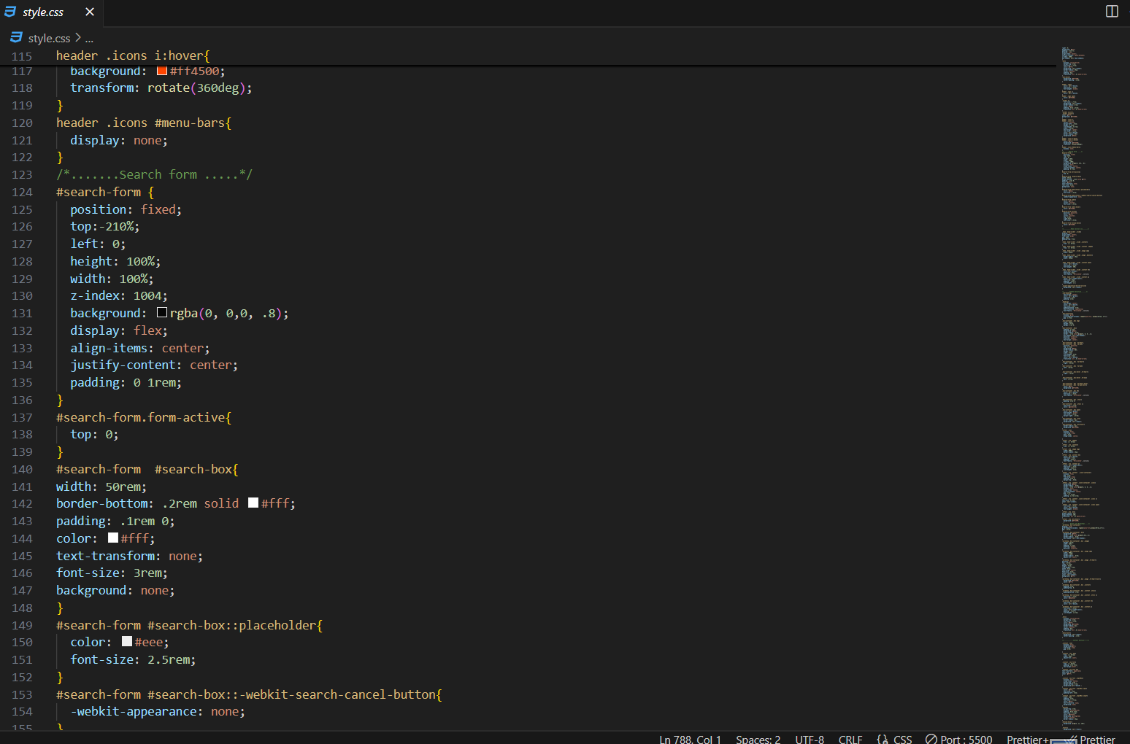

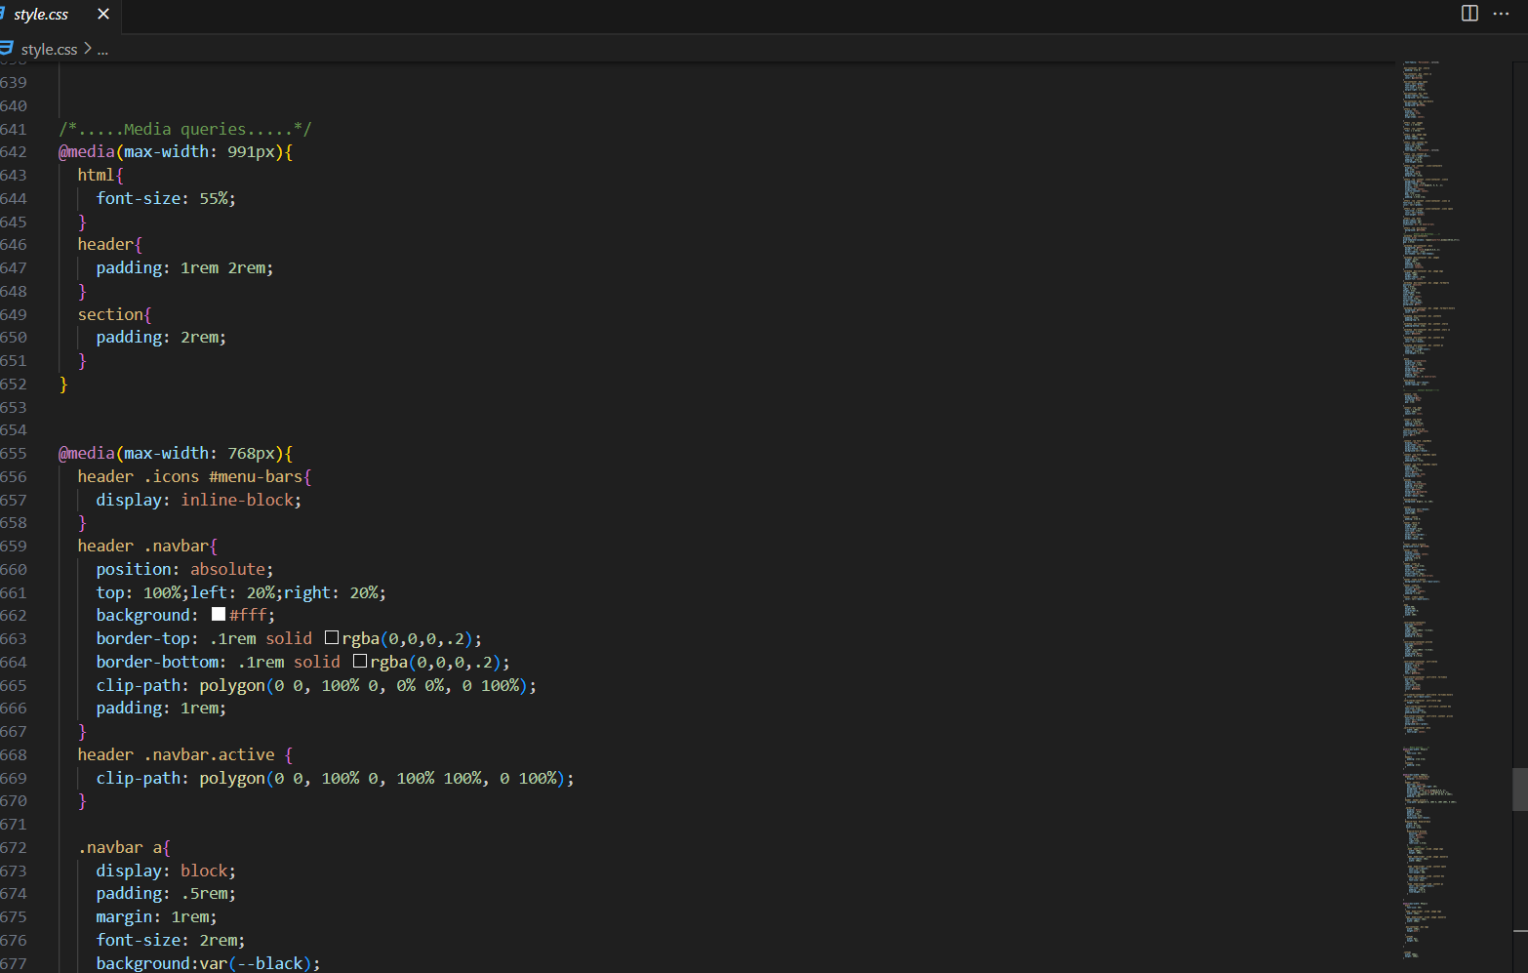

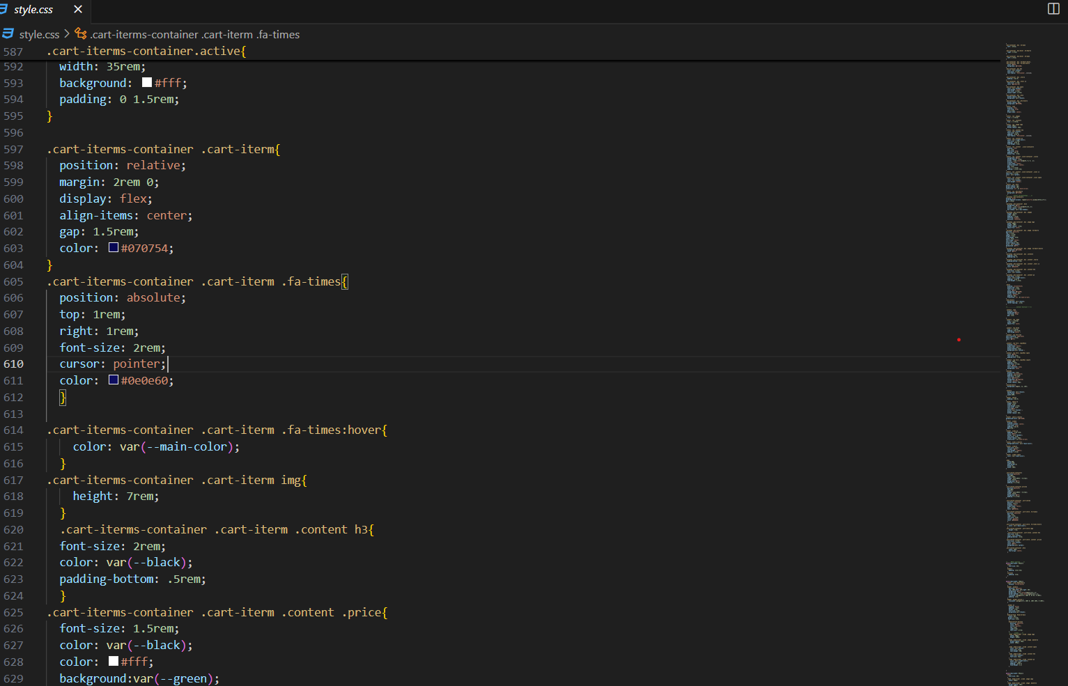

**Task 3: Website test and report**

**W3C HTML check**

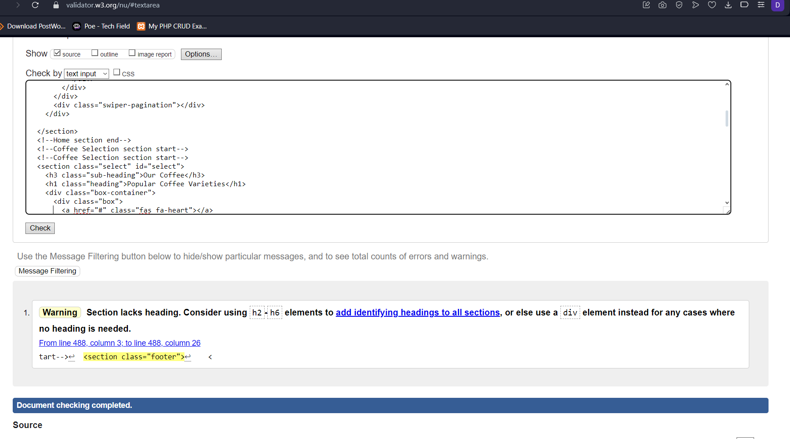

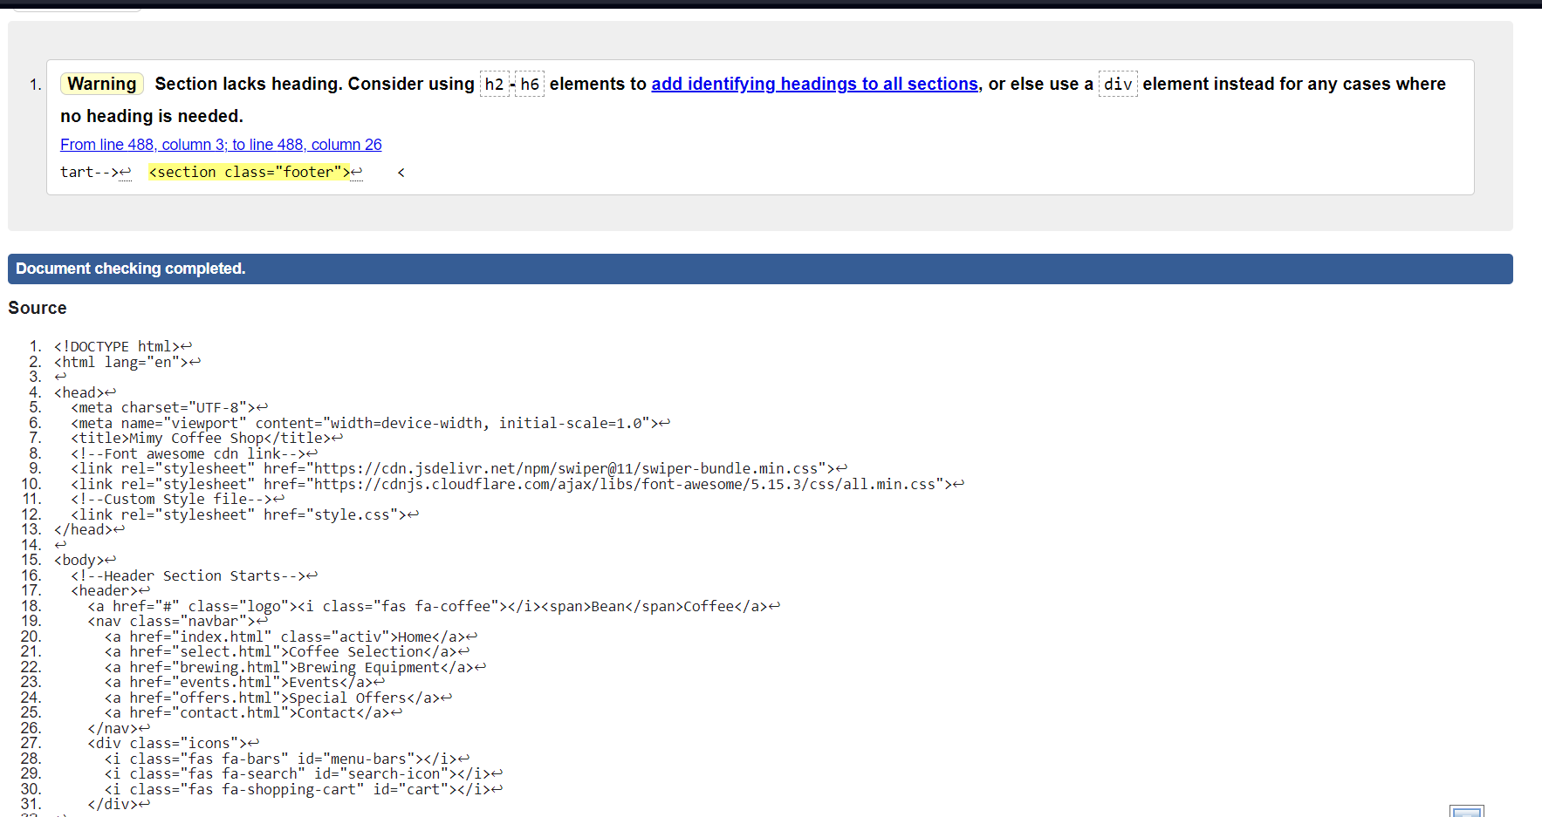

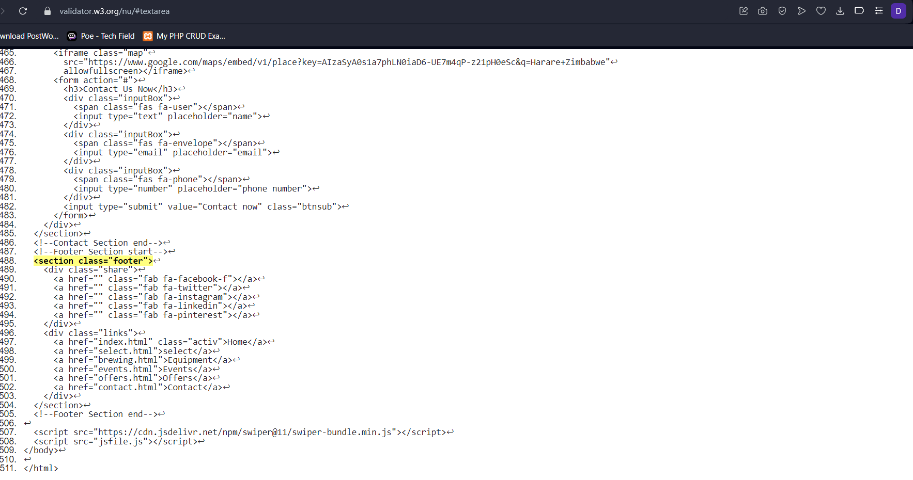

**Summary of Accessibility Testing Results:**

The website was tested with the JAWS screen reader, which revealed a few areas for improvement. Some form elements were missing associated labels, making it difficult for screen reader users to understand their purpose. Additionally, the tab order was not optimal, causing users to have to navigate the page in a less intuitive sequence.

For users with motor impairments, the website generally performed well. Keyboard-only navigation was mostly smooth, allowing users to access all content and functionality. However, a couple of interactive elements were challenging to operate without a mouse.

Regarding visual accessibility, the website met WCAG color contrast guidelines, supporting users with low vision. The content structure and organization were logical, which should aid users with cognitive disabilities. However, the reading level of some sections may be too advanced for certain users.

**Website tests on different websites**

**Test on Chrome in a mobile device**

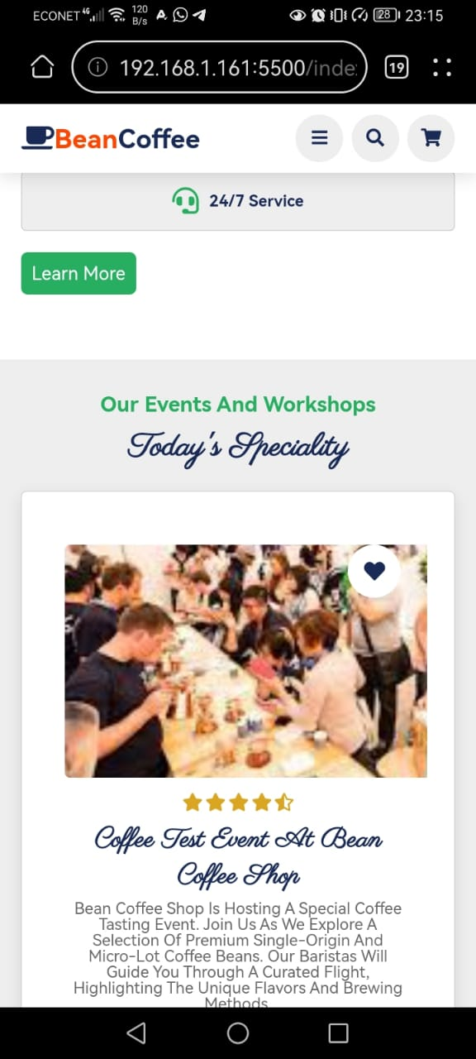

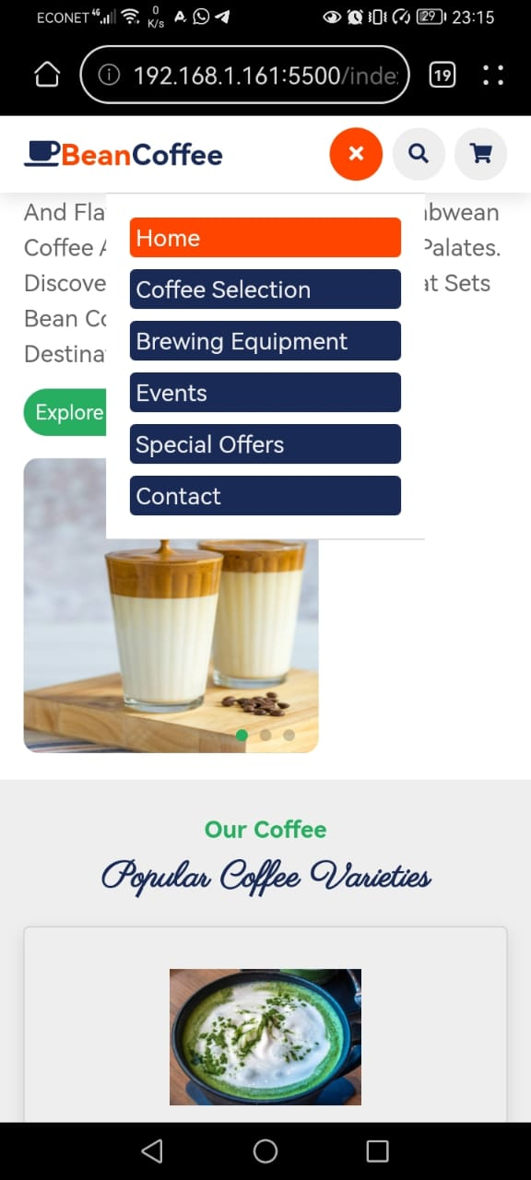

**Test on opera in a mobile device**

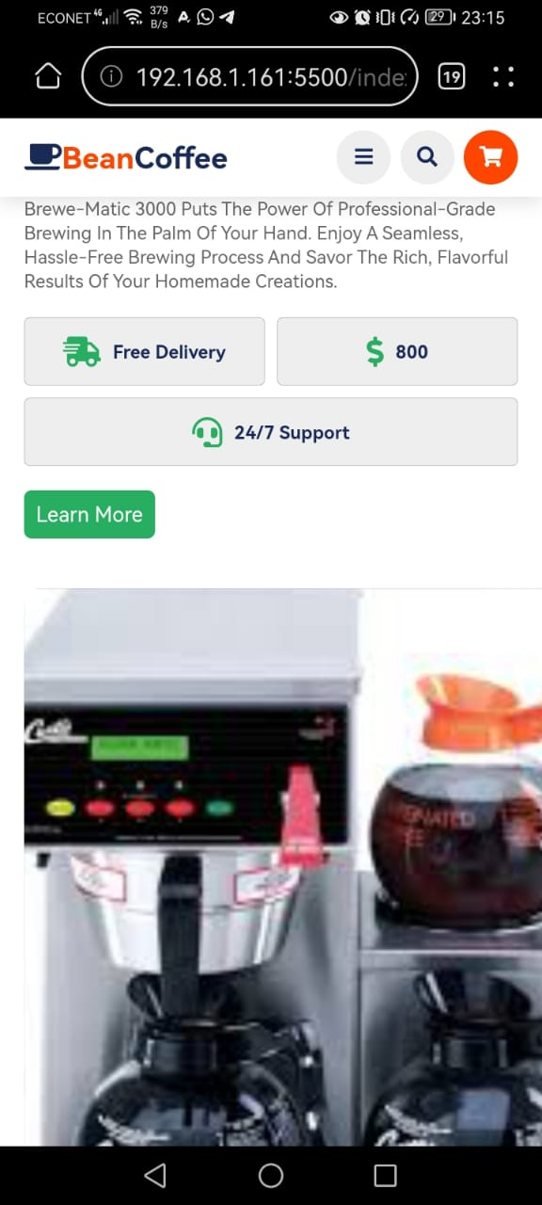

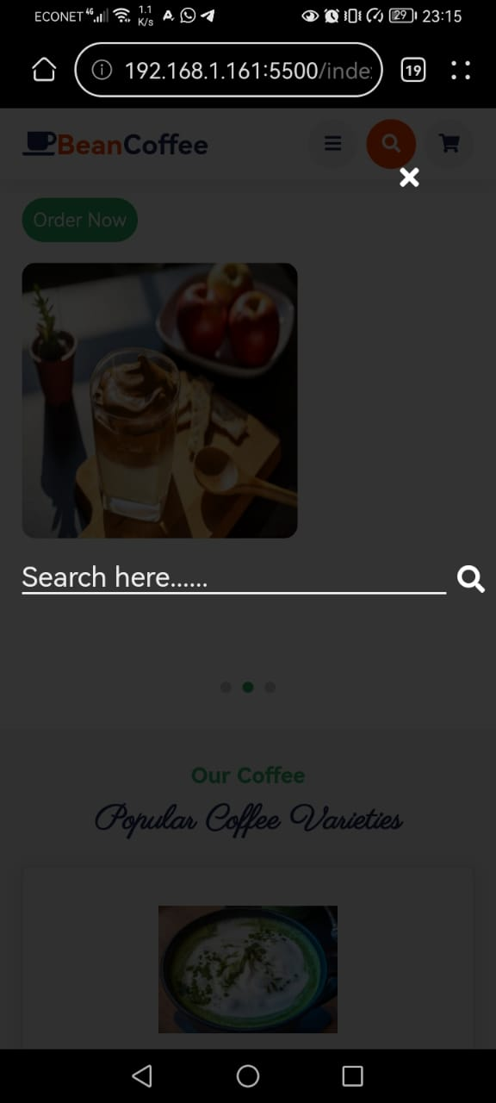

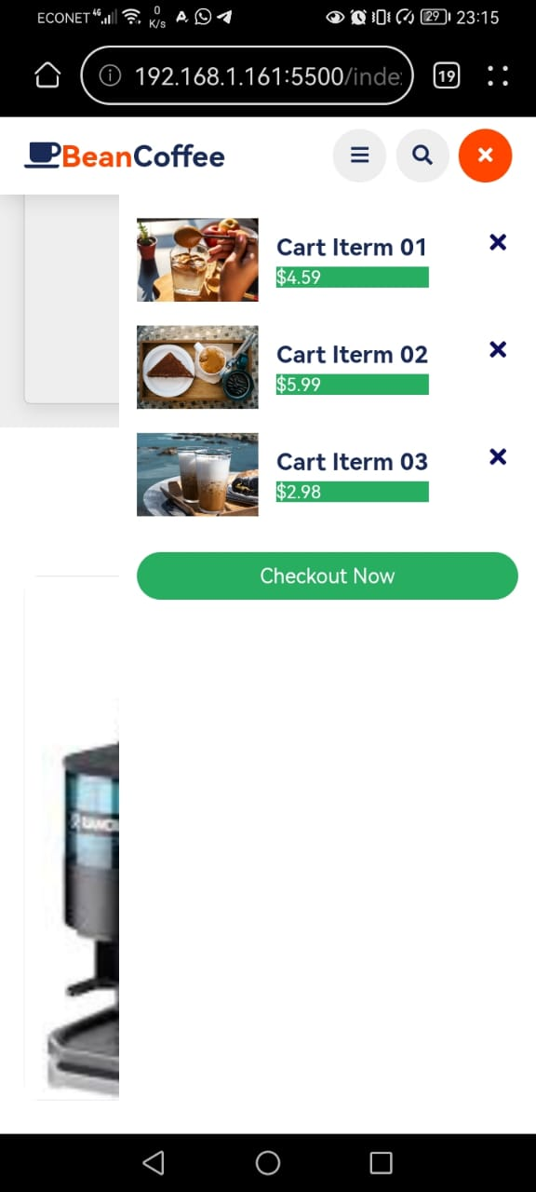

**Test on Chrome in Computer**

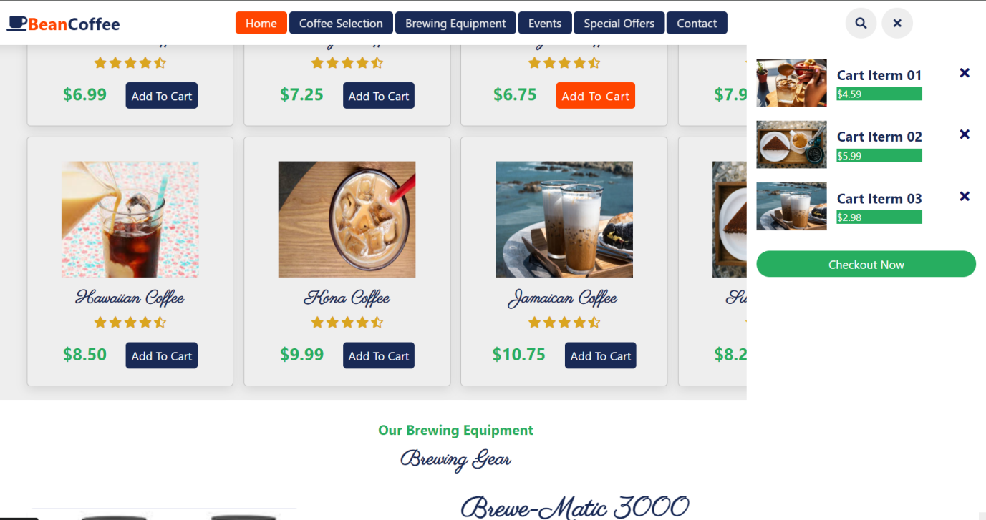

**Summary of Accessibility and Enhancements:**

After conducting a comprehensive accessibility evaluation of the website, I have made significant improvements to address the key issues identified. Here is a summary of my findings and the steps I have taken to enhance the accessibility of the site:

**Inconsistent Heading Structure**

During my testing, I found that the heading hierarchy throughout the website was not consistently structured, making it challenging for screen reader users to navigate the content effectively.

To remedy this, I have thoroughly reviewed the page content and restructured the headings to follow a logical, hierarchical order (e.g., H1, H2, and H3). This ensures that users can easily perceive the organization and relationships between different sections of the website.

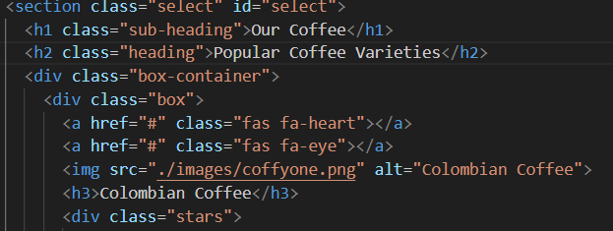

**Unclear Form Field Labels**

Several form fields on the website were found to be missing appropriate labels, making it difficult for users with screen readers to understand the purpose of each input.

I have now ensured that all form fields are properly associated with corresponding labels, providing clear context for users. Additionally, I have implemented the use of the aria-label attribute to further enhance the accessibility of form elements.

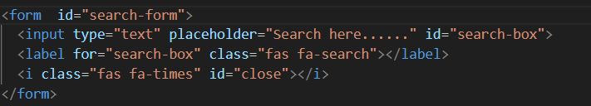

**Accessibility Testing Report Summary**

**Methodology**

The accessibility evaluation of the company website involved a combination of automated tool reviews, manual inspections, and user testing with individuals who have various disabilities. The assessment was based on the Web Content Accessibility Guidelines (WCAG) 2.1, which serve as the industry standard for web accessibility.

**Key Findings**

The overall accessibility of the website was found to be quite strong, with the majority of WCAG criteria being satisfactorily met. However, a few notable issues were identified:

Keyboard Navigation Challenges: The expandable sub-menus in the main navigation presented some difficulties for users relying on keyboard-only interaction, with inconsistencies in focus management and menu functionality.

Lack of Proper Heading Structure: The heading hierarchy throughout the website was not consistently structured, which could make it challenging for screen reader users to understand the organization and relationships between different content sections.

**Recommendations**

To address the outstanding accessibility problems, the following improvements are suggested:

Review and enhance the sub-menu functionality to ensure a consistent, intuitive keyboard interaction model that aligns with WCAG guidelines.

Conduct a comprehensive audit of the heading structure across the website, restructuring the headings to follow a logical, hierarchical order (e.g., H1, H2, and H3).

Thoroughly examine all form elements and add appropriate labelling, using techniques such as the aria-label attribute, to provide clear, accessible information for users.

**Role of the W3C**

The World Wide Web Consortium (W3C) is the leading organization responsible for developing web standards, including the WCAG. They play a crucial role in promoting digital accessibility by establishing guidelines, collaborating with stakeholders, and driving the adoption of accessibility best practices worldwide.

**Task 4:**

**Critical Evaluation of the Bean Coffee Website**

**a) Back-end Technology and Front-end vs. Back-end Web Development**

To create the Bean Boutique website, a range of back-end technologies would be required. The back-end refers to the server-side components that handle the core functionality, such as data storage, processing, and logic. For the Bean Boutique, the back-end could be built using server-side programming languages like PHP, Python, or Node.js. These would be used to create the application logic, manage user interactions, and integrate with a database system.

**b) Evaluation of Plugins**

The Bean Boutique website has included three plugins: Woo Commerce, Yeast SEO, and Contact Form 7. Woo Commerce is a popular e-commerce plugin for WordPress that provides features for online stores, such as product management, shopping carts, and order management. Yeast SEO enhances the website's visibility, while Contact Form 7 enables customer communication. These plugins align well with the needs of the Bean Boutique website.

**c) Version Control and GitHub**

Version control is the management of changes to documents, computer programs, and websites. It allows developers to track and control modifications, collaborate effectively, and maintain a history of the project's evolution. Git is a popular distributed version control system, and GitHub is a web-based hosting service for Git repositories.

**d) Front-end Development Frameworks and Bootstrap**

Front-end development frameworks, such as Bootstrap, provide a structured and modular approach to building the user interface. They offer features like responsive design, UI components, and built-in functionality, streamlining the development process. Employing a framework like Bootstrap can improve cross-browser compatibility and provide a consistent user experience.

**e) Unique Selling Points, Value-adding Technology, and Recommendations**

The Bean Boutique website's unique selling points include effective customer communication through the Contact Form 7 plugin and the comprehensive e-commerce capabilities provided by the Woo Commerce plugin. The Woo Commerce integration has been the most valuable technology, enabling the website to function as a fully-fledged online store.

To further enhance the Bean Boutique website, the incorporation of a front-end framework like Bootstrap could be considered. This would improve the website's responsiveness, consistency, and overall user experience.